**Employee Information Form**

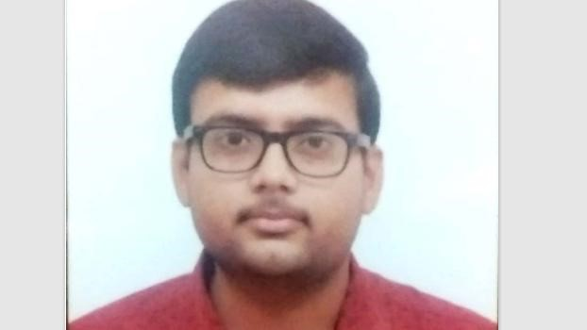

**Photograph**

**(Note: Kindly write all in CAPITAL letters except for email id)**



|  |  |
| --- | --- |
| Employee Name  (First, Middle,  Last) | Himanshu Bansal |
| Emp. Id | 6464 |
| Designation | ASSOCIATE SOFTWARE ENGINEER-TRAINEE |
| Personal E-mail Address | himanshubansal123654@gmail.com |
| Dept. / Division | SES |
| Date of joining (DD/MM/YYYY) | 29/11/2021 |

**Personal Information:**

|  |  |  |
| --- | --- | --- |
| Father’s Name: | SANJAY BANSAL | |
| Gender (M or F) | MALE | |
| Date of birth  (DD/MM/YYYY) | 7/2/1999 | |
| Marital status    Spouse Name:  Spouse’ Date of birth  (DD/MM/YYYY | Married Single ✓ | |
| Blood group |  | |
| Current Address (with PIN code)  Contact No | **KRISHANPURI ,INFRONT OF CIVIL HOSPITAL MORAR GWALIOR(474006)**  (+91) (0751) (9131894604) | |
| Permanent  Address  (with PIN code)  Contact No | **KRISHANPURI,INFRONT OF CIVIL HOSPITAL MORAR GWALIOR(474006)**  (+91)(0751)(9131894604) | |
| Mobile Number | 9131894604 | |
| Passport details | No:  Place of issue:  Date of Issue:  Expiry Date: | |
| Driving licence details | No:  Place of issue:  Date of Issue:  Expiry Date: |  |
| Do you have any relatives in THBS | Yes No ✓ | If yes, mention the name: |
| Languages Known | Languages Read Write Speak  1.ENGLISH YES YES YES  2 HINDI YES YES YES  3.  4.  5. | |

**Emergency Contact Details** (for emergency notification purposes only)

|  |  |  |
| --- | --- | --- |
| Name | MADHU BANSAL |  |
| Relation | MOTHER |  |
| Address | KRISHANPURI MORAR GWALIOR |  |
|  |  |  |
|  |  |
| Contact Number | Work:HOUSEWIFE | Home / Mobile:8827416028 |

**Parents/Spouse Contact Details**

|  |  |  |
| --- | --- | --- |
| Name | SANJAY BANSAL |  |
| Relation | FATHER |  |
| Address | KRISHANPURI MORAR GWALIOR |  |
|  |  |  |
|  |  |
| Contact Number | Work:BUSINESS | Home / Mobile:9926916028 |

|  |  |
| --- | --- |
| Total Relevant Experience (Months): | 0 |

**Local Friends/Relatives/Guardian Contact Details**

|  |  |  |  |
| --- | --- | --- | --- |
| Name | TARUN BANSAL |  |  |
| Relation | COUSIN BROTHER |  |  |
| Address | BANGALORE |  |  |
|  |  |  |  |
|  |  |  |
| Contact Number | Work: |  | Home / Mobile:9929387105 |

**Qualification details:**

|  |  |  |  |  |  |
| --- | --- | --- | --- | --- | --- |
| Qualification | College / Institute  Name | Year of Passing | Subject of  Specialization | % or Grade  Secured | Remarks  (University) |
| X | PRAGATI VIDYA PEETH | 2015 |  | 7.4 CGPA | CBSE |
| XII | PRAGATI VIDYA PEETH | 2017 | PCM | 63% | CBSE |
| Diploma |  |  |  |  |  |
| Graduation | ITM GROUP OF  INSTUTUION  GWALIOR | 2021 | COMPUTER SCIENCE | 8.3 CGPA | RGPV |
| Post  Graduation |  |  |  |  |  |

**Professional Experience:**

To,

The HR Department

**Torry Harris Business Solutions** Bangalore

This is state that I will be submitting the following documents by the below mentioned dates:

|  |  |  |
| --- | --- | --- |
| **Documents for submitting** | **Submission dates** | **Reason for delay** |
| Relieving letter from previous employer |  |  |
| Experience letter from the previous employer |  |  |
| Copies of Educational Certificates   1. X 2. XII 3. Diploma 4. Graduation 5) Semester wise marks cards | 29/11/2021 |  |
| Last Salary Slip / Proof of Last Salary Drawn |  |  |
| Copy of passport | Not Available |  |

Signature of the employee:



Date:

29/11/2021

**E-MAIL ACCOUNT CREATION FORM**

|  |  |  |
| --- | --- | --- |
| **Employee Name** | HIMANSHU BANSAL |  |
| **E-mail account ID** | himanshu_bansal@thbs.com | **Example:**  ***First name Last name***  *First name_last name@thbs.com* |
| **Date submitted (DD/MM/YYYY)** | 29/11/2021 |  |
| **Employee ID** | 6464 |  |
| This is to state that I will utilize the e-mail id only for official purpose and will not misuse it.  **Signature of employee:** | | |
|  | **Approval (HR Manager)** | |
| **Date** |  |  |
| **Name** | Shivdayal Charan |  |
| **Remarks** |  |  |
|  |  | **Signature:** |
|  | **Approval (IT)** | |
| **Date** |  |  |
| **Name** |  |  |
| **Remarks** |  |  |
|  |  | **Signature:** |
|  | **System Administrator** | |
| **Created** |  |  |
| **Date Created** |  |  |
| **Informed to the requester** |  |  |
|  |  | **Signature:** |